

|  |  |
| --- | --- |
| **International Waste Recovery and Valuation Exhibition “REVADE”**  **October 09th to 12th, 2017** | Technical datasheet |

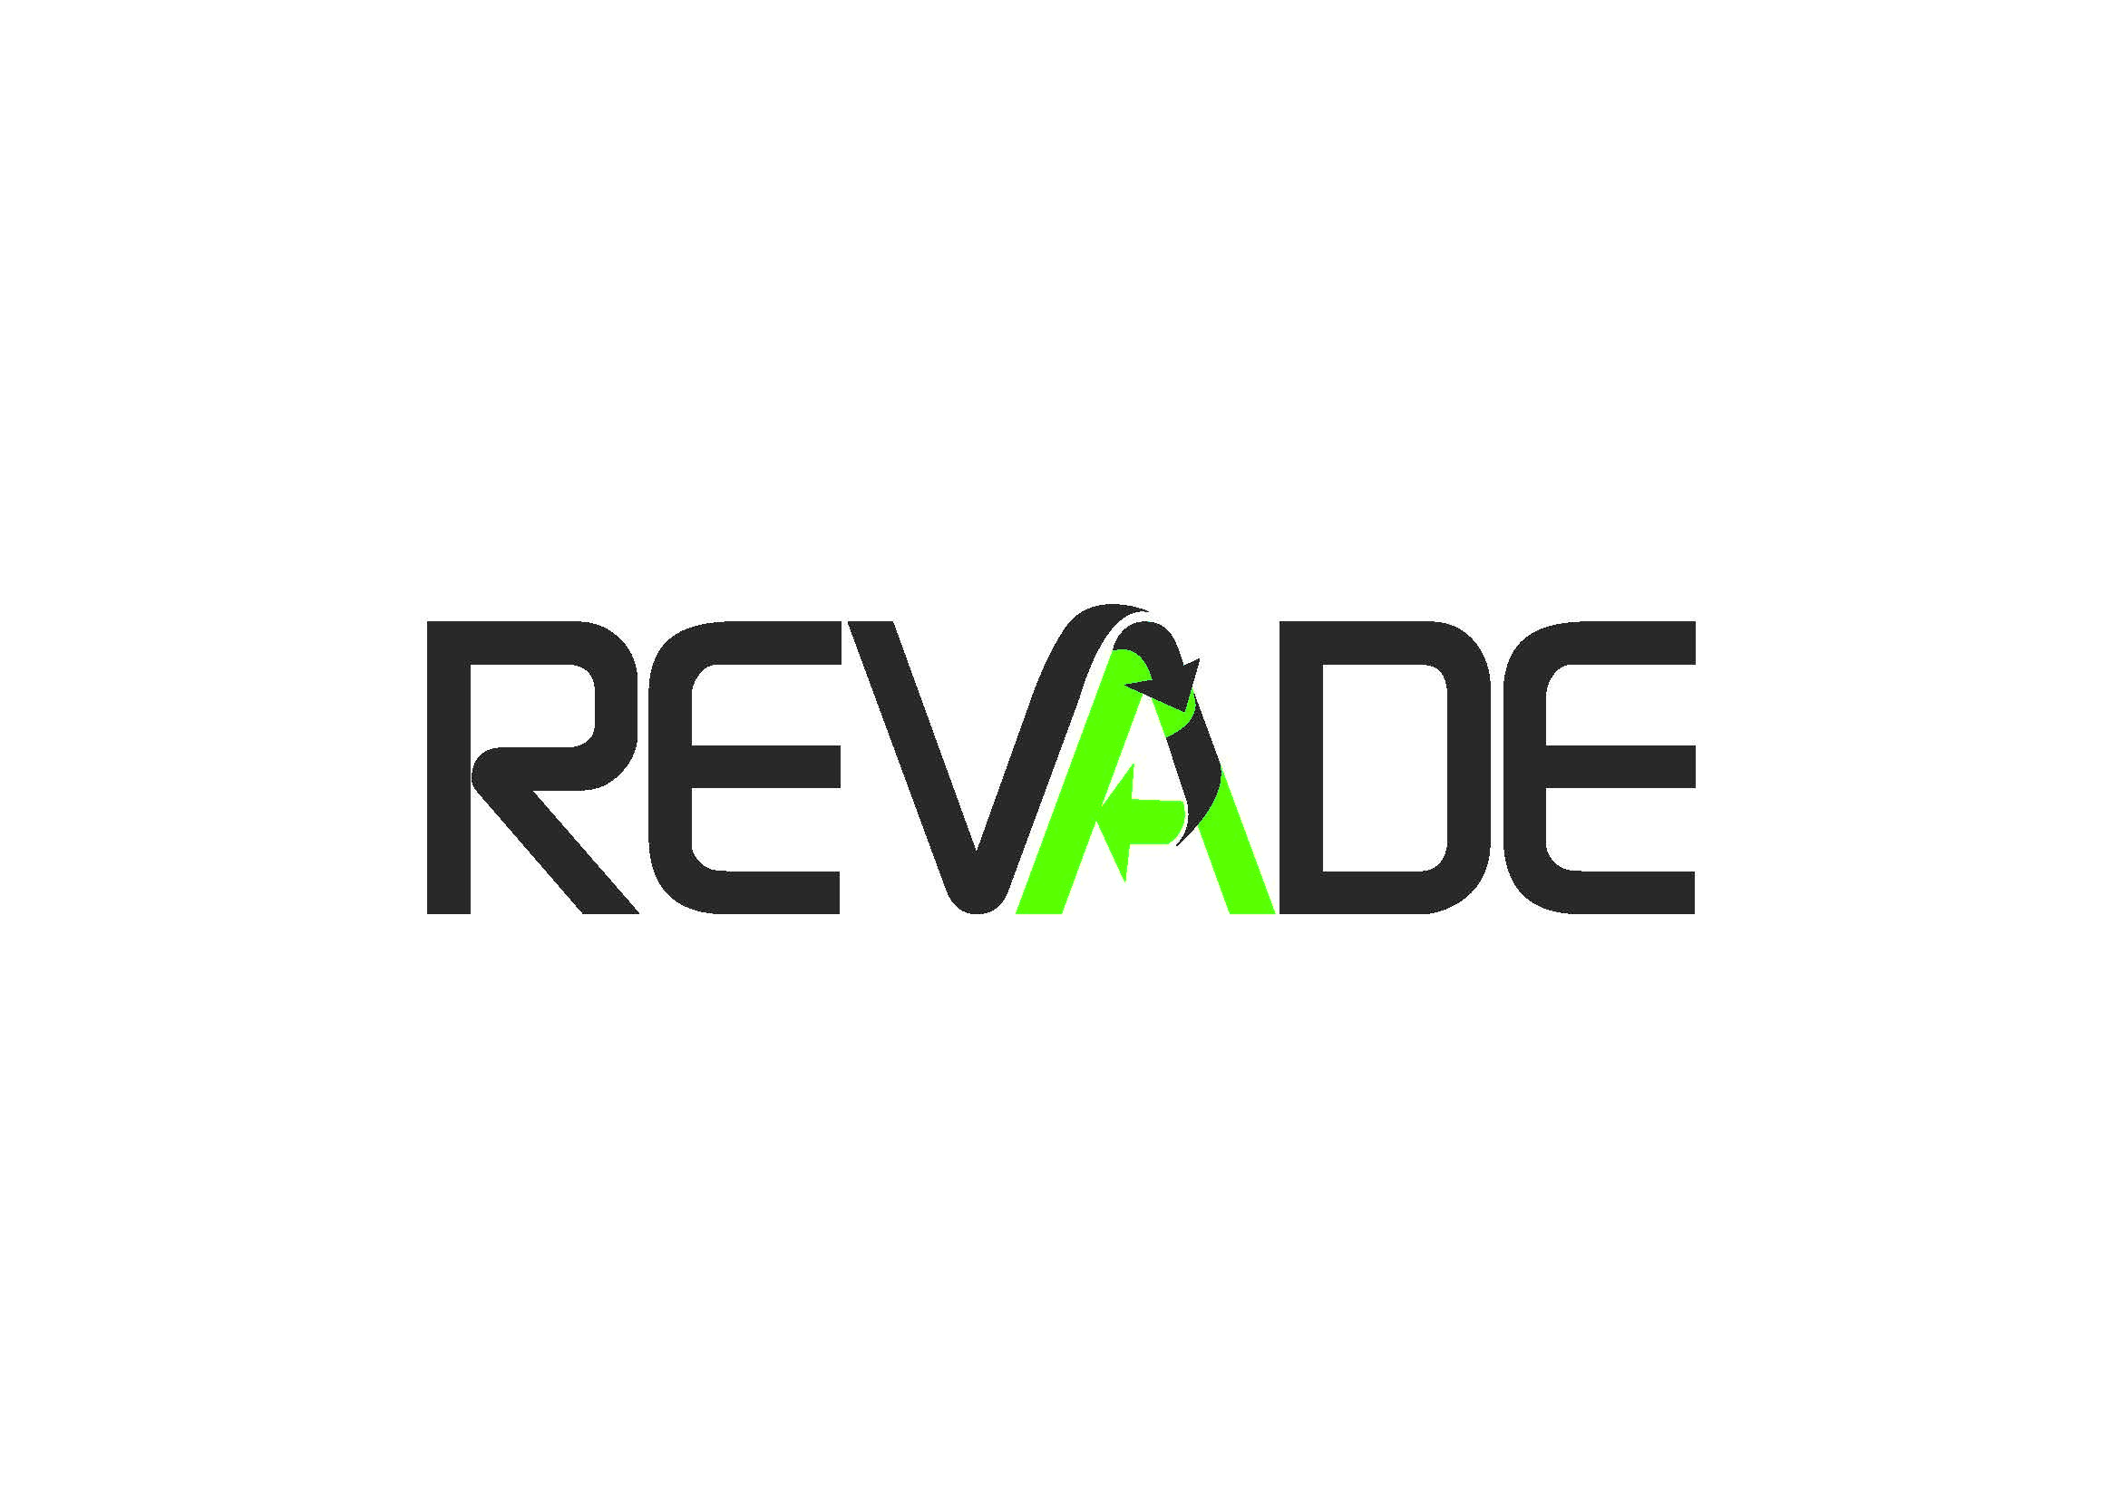

[***www.revade.dz***](http://www.revade.dz)

**Introduction:**

The activity of recovery and the valuation of the wastes which was previously a purely environmental concern, has become an economic activity since it can generate a financial value of 38 billion DA / year and could create a great number of direct and indirect employment (7 600 jobs can be created in the polyethylene terephthalate field which generates about 350 000 tons / year).

Recent statistics show that there is a market of about 300 000 tons / year of special waste (tires, worn oil, batteries and 3E wastes) among which only 150 000 tons are valued and exploited. As a matter of example:

* about 16 companies activate in the collection and the export of worn oil ;
* about 10 private companies activate in the recycling and the valuation of the worn tires and make mainly carpets of roads and the aggregate of which the market remains very promising ;
* several American, French and South African companies showed their big interest to realize industrial poles in the IT recycling.

This clearly shows that the sector of waste recycling in Algeria is left not developed. On another level, the reduction of external financial resources of Algeria encourages us to seek new ways and new means to contribute to the substitution of local production to imports, to maximize the productive resources available in Algeria especially by the recovery and the recycling of waste and to encourage investment in new activities and the creation of new businesses.

It is in this context and taking into account the success which knew the first edition of the International Exhibition of Waste Recovery and Valuation “REVADE”, the CACI organises in association with the National Agency of Waste (AND) the 2nd edition of the REVADE which is dedicated to the collection, the sorting, the transport, the processing, the valuation and to the waste recycling.

The datasheet aims to set guidelines of this exhibition project.

**Description:** International Exhibition of Waste Recovery and Valuation “REVADE”

**Type:** Professional

**Edition:** 2nd Edition

**Date:** October, 09th – 12th, 2017

**Place:** Pins Maritimes Palais des Expositions, Algiers.

**Duration:** 04 days

**Organizer and owner:** Algerian Chamber of Commerce and Industry

**Patronage of the exhibition:**

* The Ministry of Water Resources and Environment
* The Ministry of Industry and Mines
* The Ministry of Commerce

**Exhibition partners:** AND, SAFEX, ANVREDET

**REVADE 2016 :** The first edition publishing of the REVADE exhibition which took place from 05 till 08 october 2016 which has seen the participation of 30 Algerian and foreign companies which activate in the sector of the collection, the transport, the sorting and the processing of waste and more than 3 000 professional and public visitors have to visited the exhibition and participated in the conferences which took place on the 06th and 07th October in the same space as the exhibition.

Economic broadcasts concerning the theme of the exhibition were broadcasted in the Algerian media channels before, during, and after the exhibition.

**The exhibition aims to :**

* Make know the equipment and the technologies used in the field of transformation and recycling wastes;
* Promote the waste recovery and recycling industry and encourage investment and new the creation of new companies;
* Promote and develop the management and the recovery of industrial wastes.

**Companies / activities admitted to the exhibition are :**

1. **Collection and transportation :**

* Collection and transportation of ferrous wastes
* Collection and transportation of packaging wastes
* Collection and transportation of plastic wastes
* Collection and transportation of textile wastes
* Collection and transportation of chemicals and toxic wastes
* Collection and transportation of Electronics, Electrical and Appliances wastes
* Collection and transportation of used tires
* Collection and transportation of oils and lubricants
* Collection of other kinds of wastes

1. **Equipments for collection and transportation :**

* Equipments for the collection and transportation of ferrous wastes
* Equipments for the collection and transportation of used tires
* Equipments for the collection and transportation of oils and lubricants
* Equipments for the collection and transportation of packaging wastes
* Equipments for the collection and transportation of plastic wastes
* Equipments for the collection and transportation of textile wastes
* Equipments for the collection and transportation of chemicals and toxic wastes
* Equipments for the collection and transportation of Electronics, Electrical and Appliances wastes
* Equipments for the collection and transportation of kinds of wastes

1. **Equipments for processing and recycling :**

* Equipments for the Processing and recycling of ferrous wastes
* Equipment for the processing and recycling of packaging wastes
* Equipments for the processing and recycling of plastic wastes
* Equipments for the Processing and recycling of oils and lubricants
* Equipments for the Processing and recycling of used tires
* Equipments for the processing and recycling of chemical and toxic wastes
* Equipment for the processing and recycling of Electronics, Electrical and Appliances wastes
* Equipment for the processing of industrial waste water
* Equipment for the processing of other kinds of wastes

1. **Processing and recycling :**

* Selective sorting of the industrial waste
* Processing and recycling of packaging wastes
* Processing and recycling of plastic wastes
* Processing and recycling of chemical and toxic wastes
* Processing and recycling of Electronics, Electrical and Appliances wastes
* Processing and recycling of used tires
* Processing and recycling of oils and lubricants
* Processing and recycling of other kinds of wastes

1. **Services :**

* Technical landfills
* Inceneration plants
* Management of sorting centers and technical waste burying
* Industrial waste management Research and consultancy
* Public institutions and organizations
* Wastes incineration centers
* Technical waste burying
* Processing of industrial waste water

**The conferences program of the exhibition:**

Several conferences will be given by national and foreign experts in relation with the theme of the exhibition.